KNIPSS - Information Technology Center (ITC):

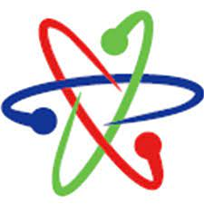 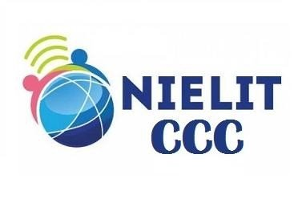

­­­­­­ **Spoken English**

**Teach Your tongue to Speak English**

Select one just Rs. @ 1500 Only

**Tally**

Power of Simplicity